https://www.sjc.edu/admissions-and-aid/undergraduate-admissions/contact-admissions/ask-student

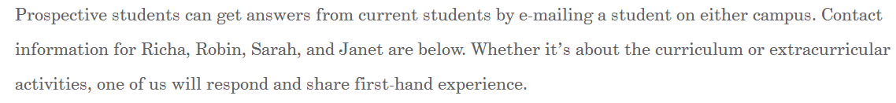

CHANGE TO:
Prospective students are invited to ask questions of current students by clicking on the below e-mail addresses. Our students will respond and share their first-hand experiences.

