Website additions

LEAD Sponsor (add sponsor level)
(2nd highest $ category under Premier Lead Sponsor)
Sun Power Solar at https://www.positiveenergysolar.com/about-us/who-we-are/
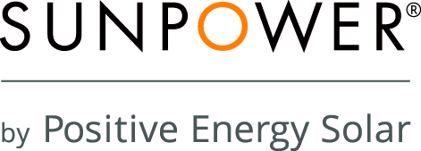

BAND Sponsor
http://www.deborahtrouw.wrfa.com/

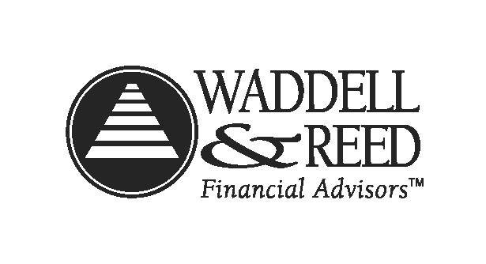

Media Sponsor
Add a fourth sponsor—
https://www.abqjournal.com/north

Partner Sponsors
No changes

Supporter Sponsor
Add the names:
DMC Construction http://www.dmaahsconstruction.com/ (logo coming)
Jennifer and Jimmy Day (no link)
Monica McLin, Keller Williams Realty http://www.kw.com/kw/agent/monicamclin

