Sponsors and Friend of Music on the Hill
- Change : “Senior Sponsor” to “Senior Partner Sponsor”
- Move Walter Burke Catering to “Partner Sponsor” section
- Move New Mexico Arts to its own section after “Supporter Sponsors” and add text: “This project is supported in part by New Mexico Arts, a division of the Department of Cultural Affairs, and the National Endowment for the Arts.”
- Remove Brookdale from Sponsor section completely.
- Add logo for DMC construction (esp file logo uploaded)
- Add Southwest CARE Center to “Supporter Sponsors” section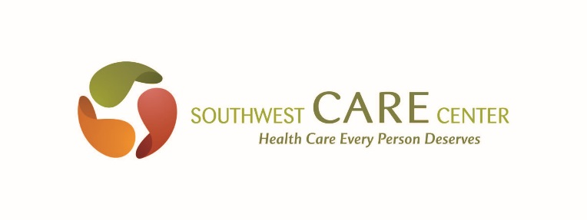 https://southwestcare.org/

Volunteers
- Remove “Tom Eakes, The Holy Company” from Thank you to Advisory Board.
- Remove the following text :
“More information (parking, guidelines, cancellation policies) coming in the spring of 2017. “

