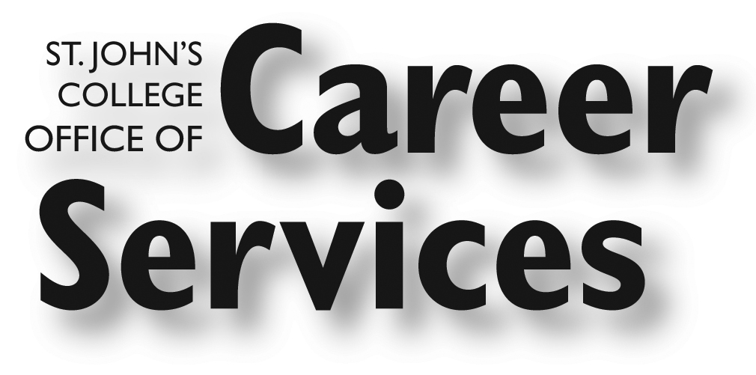
Pinkney Hall
410-626-2501
Annapolis.careerservices@sjc.edu

Calendar of Events
November & December 2017

November 2017

Career Services Open House for Parents’ Weekend
Friday, November 3, 2:00 – 4:00 pm, Career Services Office

Visit the Career Services office to learn more about upcoming programs and initiatives that will help your student succeed in his or her career path after graduation.

Parents’ Luncheon with Hodson Interns
Saturday, November 4, 12:00, FSK Lobby

Join Hodson interns from the summer of 2017 to hear about their internship experiences and the benefits of participating in the program. A buffet lunch will be provided.

Arts Administration Information Session with Recent Alumni
Tuesday, November 7, 5:00, Klein Conference Room

More details will follow! Please RSVP to Kathleen Cady if you’d like to attend (Kathleen.cady@sjc.edu).

Peace Corps Information Session
Wednesday, November 8, 2:30, Klein Conference Room

Launch your international career with the Peace Corps. Come chat with recruiter Sarah Timpy about opportunities to live, learn, and work with a community overseas. She will also tell you about Peace Corps' new, shorter, simpler application and choice-based assignment selection process.

Pathways Fellowship Info Session

Tuesday, November 14, 3:45, Conversation Room, Mellon

The Pathways Fellowship enables St. John’s students to transition into graduate study or careers that call for special or prerequisite courses. Find out how you can apply for a grant

of up to $2,500 to use toward summer courses or programs related to your career exploration!

The fellowship is open to current sophomores, juniors, and seniors.

Great Hearts Academies Information Session & Interview Opportunity
Wednesday, November 15, 2:30, Mellon Conference Room, Mellon

Join Kiann Mapes, who will speak with prospective teachers about their network of academies in Arizona and Texas. Pre-arranged interviews will be held on 11/15 and 11/16.

December 2017

Conversation with Professor Bernhardt Trout
Friday, December 1, 3:45 pm, Klein Conference Room, Hodson House

Professor Trout, who will be the Friday night lecturer, will be on campus to talk with you about his research and careers in the areas of engineering, physics, and mathematics. He holds an S.B. and S.M. from MIT and a PhD from the University of California, Berkeley. At his lab at MIT, Prof. Trout, develops and applies sophisticated computational, theoretical, and experimental methods in order to probe complex chemical systems on the molecular level and engineer them for high value chemical applications with maximum specificity. He will be open to your questions about his areas of expertise.

