JohnnieTalks
Saturday, September 14, 2019
4:30 – 5:30 p.m.
Meem Library, Ault-Evers Room (2nd Floor)
St. John’s College, Santa Fe

JohnnieTalks features seven dynamic alumni speakers presenting lightning talks in the PechaKucha style. Each speaker will have just 20 seconds per slide to get through 20 slides—ensuring a fast-paced and lively presentation on a compelling theme, JohnnieProud: What inspires me to uphold my community, convictions, calling, or cause. This event is free and open to all!

Taja Beekley (SF99) is the Sales and Events Manager for the new Austin Central Library, located a mile from Stephen F. Austin High School, her first alma mater. While studying at St. John’s College, Taja worked at the bookstore during her junior and senior years. Taja obtained a master’s degree at the Lyndon B. Johnson School of Public Affairs at the University of Texas. Upon receiving her degree, she joined the City of Austin, where she has been employed for over thirteen years. She takes great pride in working with the community and being surrounded by books every day.

Taja’s presentation is titled: “The Modern American Library—Life Beyond the St. John’s College Bookstore.”
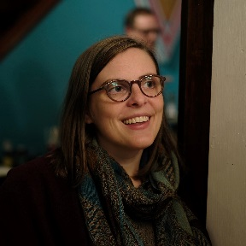
Caitlin Cass (SF09) is an artist, cartoonist and arts educator. Her comics have appeared in print and online for The New Yorker, The Washington Post, and The Nib. For the last ten years she has self-published a bi-monthly comic periodical about history and failure called The Great Moments in Western Civilization Postal Constituent. She actively exhibits her art; recent shows include Rochester Contemporary, Hallwalls Contemporary Art Center, and an upcoming exhibition at the Burchfield Penney Art Center. Caitlin was a 2018 recipient of a Fiction fellowship from the New York Foundation for the Arts (NYFA). She lives and works in Buffalo, NY, and teaches art at Buffalo Seminary, an independent all-girls high school.

Caitlin’s presentation is titled: “Pith.”

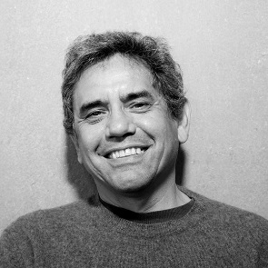
Devendra Contractor (SF79) is the founding principal of DNCA, an architectural firm based in Albuquerque, NM. With a background in the liberal arts and 35 years of experience in design and construction, he approaches his work with an innate understanding of both the tectonics and the poetics of architecture. Devendra specializes in the design of education, fine arts, and performing arts facilities. Prior to Devendra’s formal architecture education, he worked in the construction industry as a builder, site superintendent, and mason for 15 years.

Devendra’s presentation is titled: “Designing the Vladem Contemporary for the New Mexico Museum of Art.”

JohnnieTalks
Saturday, September 14, 2019
4:30 – 5:30 p.m.
Meem Library, Ault-Evers Room (2nd Floor)
St. John’s College, Santa Fe

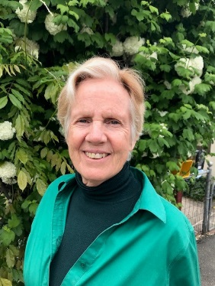
Martha Franks (SF78; EC17) spent two years in Beijing teaching a liberal arts curriculum at the Affiliated High School of Peking University (BDFZ). She brought to that task her experience as a part-time faculty member at St. John’s College in Santa Fe. At St. John’s, and then at BDFZ, she taught the classics of Western literature through discussion-based classes. Ms. Franks has had a separate career as a Southwestern water lawyer, which enabled her to offer a class in American Law to Chinese students. She is the author of Books without Borders: Homer, Aeschylus, Galileo, Melville and Madison Go to China.

Martha’s presentation is titled: “Taking the Great Conversation Global.”
Doug Lynam (SF96) is the author of the new ground-breaking book From Monk To Money Manager: A Former Monk’s Financial Guide To Becoming A Little Bit Wealthy – And Why That’s Okay, which has received enthusiastic reviews for its wisdom and thought-provoking insights told with humility and humor. A partner at LongView Asset Management, LLC, in Santa Fe, NM, Doug is an industry thought leader in ethical and sustainable investing. He founded the non-profit ESG Fiduciary™ Institute and has built pioneering environmentally and socially responsible institutional retirement plans for teachers.

Doug’s presentation is titled: “A Former Monk’s Financial Guide to Happiness.”

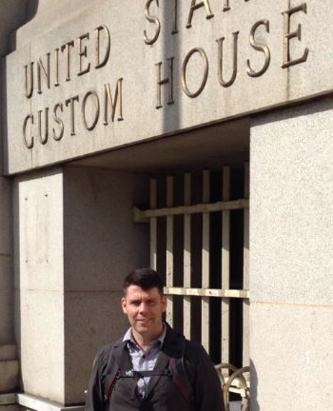
Major Alex Ruschell (SF95) serves as a Balkans analyst for the Department of Defense. Alex holds a Masters in Science (Defense and Strategic Studies) from Missouri State University, where he completed his final oral exam with distinction. Alex first enlisted in the Army in August 1996 in New Orleans, LA, with his first assignment to the 311th Military Intelligence Battalion at Fort Campbell, KY, where he earned the rank of sergeant. In 2010, Alex worked as an International Counter-proliferation Program (ICP) analyst leading course-delivery teams to Accra, Ghana; Zagreb, Croatia; Tbilisi, Georgia; and Lima, Peru.

Alex’s presentation is titled: “A Military Career as an Option for Johnnies.”

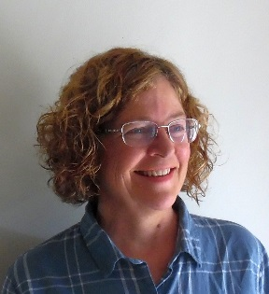
Julie Allison Spencer (SF86) is a graduate research assistant at Los Alamos National Laboratory and employs mathematical modeling to mitigate diseases on a global scale. During the years when she was raising and educating her two children, she earned a Postgraduate Certificate in Classics and co-founded Moreno Valley High School in Angel Fire, NM. Subsequently, she earned an MS in Biology at the University of New Mexico. Currently, she is a doctoral candidate at UNM, working with Helen Wearing on her dissertation, “The Evolution and Dynamics of Antibiotic Resistance in Tuberculosis.”
Julie’s presentation is titled: “Exploring Mathematical Things to Prevent Suffering.”

